SMART WATER FOUNTAIN

|  |  |
| --- | --- |
| DATE | 17-10-2023 |
| PROJECT NAME | SMART WATER FOUNTAIN |
| TEAM ID | Proj_Team_1 |

1. Introduction

* Objective:
* Today, more people around the world have pets than ever before. According to American Pet Products Association’s survey in 2020, 67% of U.S. households own a pet which is about 84.9 million homes.
* This proportion has been increased by 20% in thirty years [1]. Breakdown of the pet types, cats and dogs are the most popular animals, they contribute to about 80% of all pets. Same trend happens all over the world
* Background
* There have been quite a lot of water fountain products on the market while most of them have only filtration as an extra function besides providing running water.
* The size of the water fountain limits the capacity of the water source that most water fountains cannot store enough water for multiple pets to drink in several days.
* Our water fountain can be connected to an extra water source that provides enough water for long-term usage. The link is adaptable to universal water bottles for convenience. The sufficient water source as well as automatic replacing and refilling function enable pet owners to leave home for several days without worrying about water supply for pets.
* The size of the water fountain limits the capacity of the water source that most water fountains cannot store enough water for multiple pets to drink in several days.
* Diagram

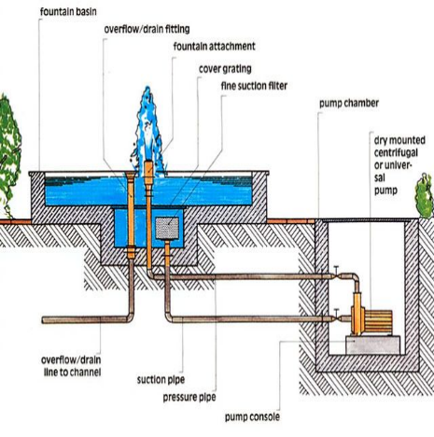

* Operation
* Able to drain the polluted water and replace it with fresh water. Specifically, the polluted water will be drained by a motor-controlled valve to the “polluted water temporary storage tank” part. After completing the draining process, fresh water will be pumped from the general water supply(as described in the right down corner of the physical design
* Working
* The block diagram below is a general design of our solution. We divide our design into four modules, including Power Supply, Control Unit, External Control, and Mechanical Unit. Details of each unit is presented in the diagram and described in the next section.

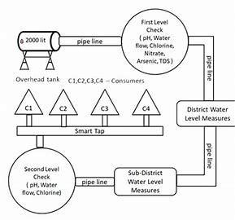

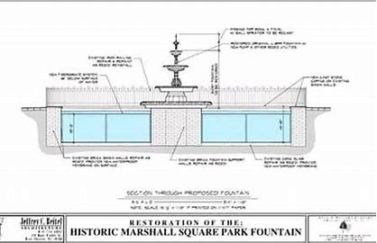

* Risk of it :
* Control Unit Block:
* One of the most challenging points in this project is the precise control of the control unit between different blocks.
* To react accurately and promptly based on the results from the sensors is the key. The control unit needs to accommodate the mechanical and the electrical part so that the pumps, draining system can work collaboratively smoothly. From acquiring the data from sensors, analyzing the data, communicating and displaying the data to users, and then sending signals to activate the corresponding actions(drain or add fresh water),
* these are all to be performed by the control unit. Thus, it is the block that brings the greatest risk.
* We will divide all the overall control unit functions into three parts:
* data retrieving,
* data manipulation,
* data delivering.
* Data retrieving is the logic used to read data from all sensors.